Year of Faith Monthly Networking Bible Study
January 22, 2013

Welcoming committee

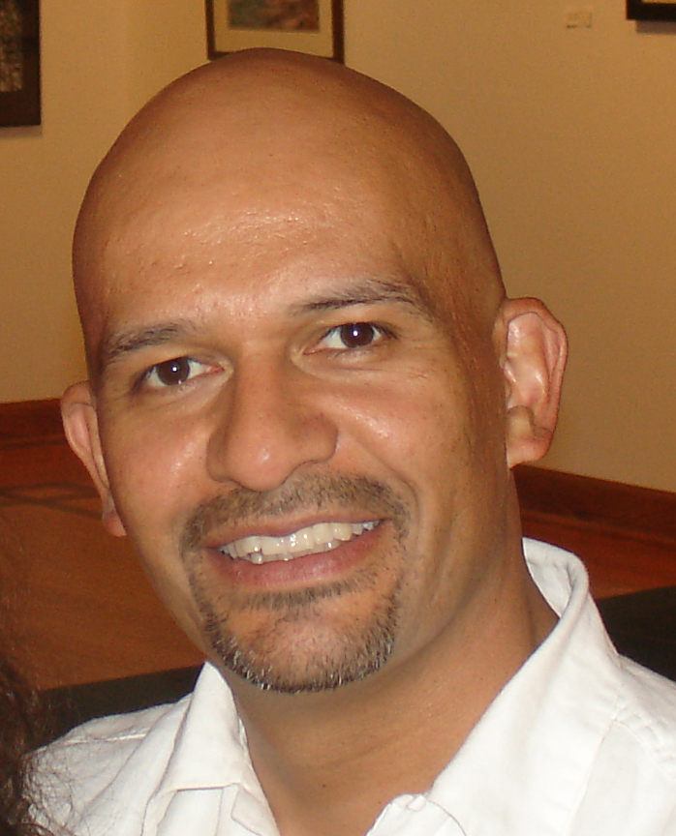
Juan Alberto Castillo, Graphic Designer, Fine Artist, Illustrator - EMI Network
Juan has almost 20 years of experience in the arts industry as a graphic designer, fine artist and illustrator. Juan serves as the lead creative designer for publications/special projects at EMI Network, a consultant to the Chicago Cubs. In addition to his artistic talent, he also uses his natural bilingual skills as he works to develop and support the Cubs' Spanish-market initiatives. In this position he draws from over 10 years of working directly for the Cubs organization, managing the design and production for the official magazine of the Chicago Cubs and other publications and special projects. For the past 14 years, his work in graphic design in both publications and marketing has had a positive impact on the Chicago Cubs organization. He earned a B.F.A. in Visual Communications from Northern Illinois University. Early in his career he won first-place on a nation-wide poster design for the celebration of the bicentennial of the Eiffel Tower. As a fine artist, his works have been shown in one-person and group exhibitions in the Chicagoland area. He loves giving art presentations to young adults and children, and currently serves as the 5th grade catechist at St. Benedict Catholic church. Whether working on a digital platform or fine art concepts, Juan Alberto produces visuals of the highest quality. 1alber2.com

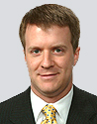
Jay Derbis, Attorney, Neal, Gerber & Eisenberg LLP
Jay Derbis is a litigation partner at the law firm Neal, Gerber & Eisenberg LLP in Chicago, where he has extensive experience defending and prosecuting matters on behalf of clients ranging from Fortune 50 multinational corporations to small businesses, individuals and state agencies. Jay has managed a broad range of complex litigation for corporate clients, including helping some of the largest Wall Street broker-dealers and banks achieve favorable outcomes in actions involving consumer fraud, contract disputes and business torts, both in arbitration and in court. Jay also has experience with a wide variety of white collar criminal and regulatory matters, including responding to state and federal inquiries, conducting corporate internal investigations and providing related compliance counseling. Jay moved to the Chicago area in 2005 from Washington, D.C., where he practiced for five years with the law firm Jones Day after having worked for two years as an Associate Independent Counsel on the federal criminal prosecution of a U.S. Cabinet secretary. Jay graduated from the Notre Dame Law School with honors in 1998. He currently lives in the western suburbs, where he and his wife spend most of their free time trying to keep up with three young sons.

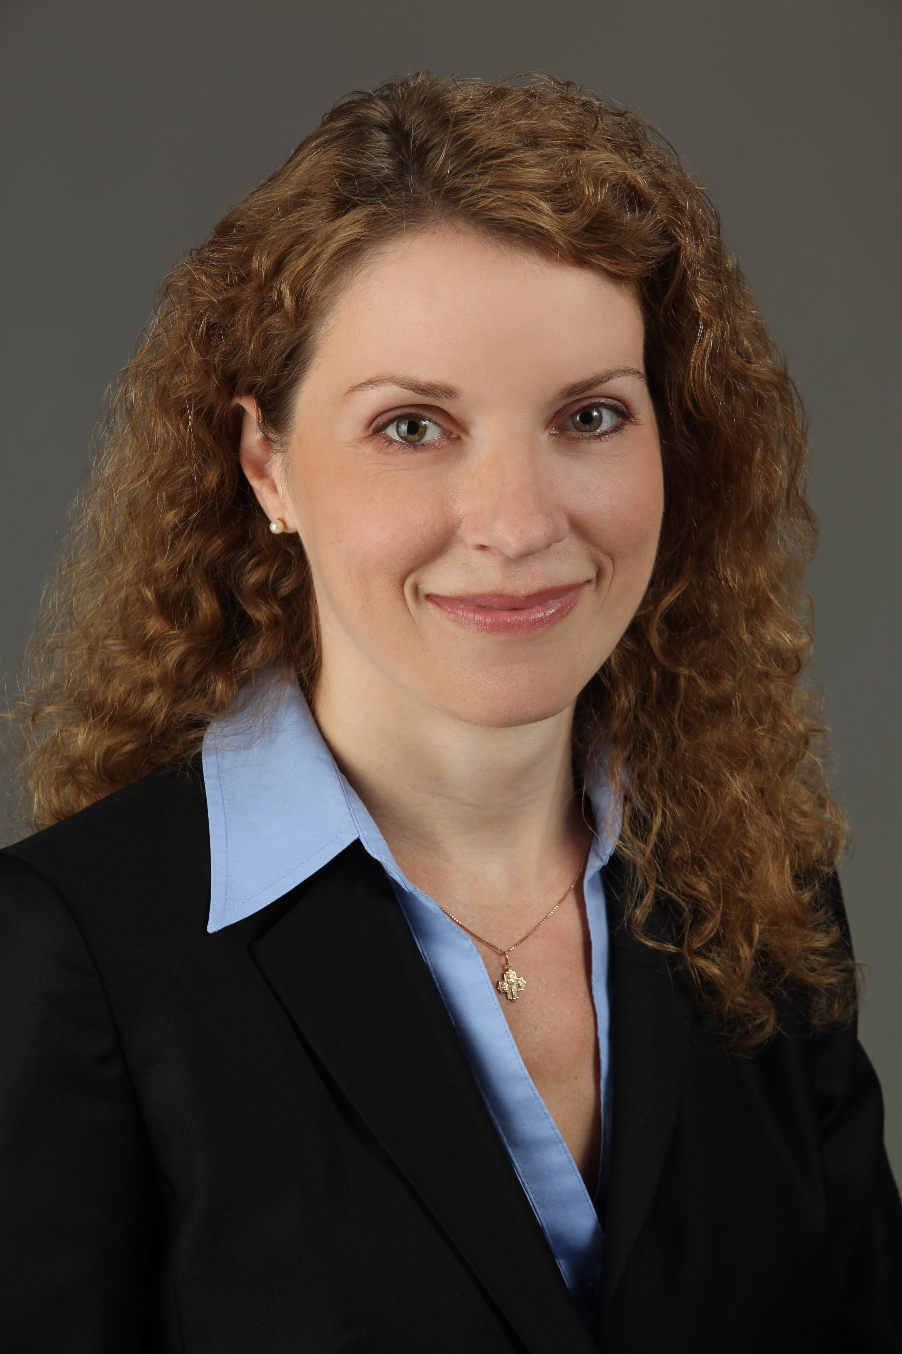
Laura Jacksack, Attorney, Jacksack Law Offices
Laura focuses her practice on political law and small business law, representing both non-profit and for-profit entities. She counsels clients on federal and Illinois campaign finance law, candidate filings, challenges, litigation, Election Day issues and post-election ballot counting and recounts. She further provides advice regarding ballot integrity issues, and ethics and campaign finance regulations. Laura also advises corporations and non-profit entities on a similar range of topics, including business formation, achieving tax-exempt status, corporate governance, and client counseling matters. She serves as outside counsel to non-profit groups, providing day-to-day legal guidance, on an as-needed basis.
Previously, Laura worked as a legislative staffer for the Illinois House of Representatives, and has directed local, state representative and judicial campaigns. Laura serves on the Board of Directors of a lawyers non-profit group dedicated to making it “easy to vote and hard to cheat” in Illinois elections. She previously served as an Executive Committee member of The 21 Club, a Chicago-based civic organization for young professionals, and volunteered as an advisor at Metro Achievement Center, advising high school girls from underprivileged neighborhoods who were the first in their families headed to college. She holds a J.D. from the University of Illinois and a B.A. in Economics and Political Science from Northwestern University.

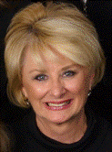
Catherine Stakenas, Associate Professor, Chicago School of Professional Psychology & Owner, CPS Corporate Consultants
Catherine joined The Chicago School Business Psychology Department in 2004 and currently holds a position as Associate Professor and course lead for Organizational Behavior and Organizational Culture and Design.

She is the founder and President of CPS Corporate Consultants, which provides coaching to clients using tools they need to educate, assess, and measure their skills, as well as, their business, and the performance of their employees. She is a specialist in building the skills required for individuals, teams, and organizations to successfully manage change. This translates into bottom line returns through increased sales, productivity, communication, and awareness. She transitioned into the corporate world managing multi-million dollar sales, service, and operations with Quest Diagnostics. As the General Manager and Regional Sales Manager for Quest Diagnostics, Catherine managed $91M in sales, service, and operations. She also served as the project manager for six of their mergers. Catherine has worked as a business coach with clients such as: ASCP (American Society of Clinical Pathology), CN Rail, Lennox Intl., Mechanical Contractor Associations, HIMSS (Health Management Systems Society), Holy Spirit Catholic Community, Y-Me Breast Cancer, the Peace Corps, and Chemical Safety Board (Homeland Security division). In addition, she is called upon to use her talents to help many Catholic organizations and parishes manage change, such as, for example, to ease transition when a new pastor arrives.

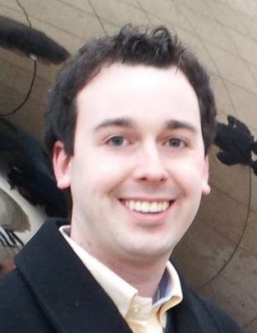
Michael Sullivan is a Senior Software Engineer at Forum Analytics, LLC. Established in 2001, Forum Analytics (www.forumanalytics.com) provides solutions to consumer-oriented firms seeking sophisticated modeling and cutting-edge mapping solutions to enhance their real estate or marketing process. In his role at Forum, Michael manages the full life cycle of software products. Prior to joining Forum, Michael spent 2 years as a web developer and analyst with a consulting firm providing content management solutions.

A former member of the Band of the Fighting Irish, Michael graduated from the University of Notre Dame in 2010 with a bachelor’s degree in Computer Science. Originally from Minnesota, Michael enjoys living in Chicago and being involved with the Notre Dame Club of Chicago and Our Lady of Mount Carmel parish in Lakeview. Michael is an avid baseball fan, and is well on his way to achieving his goal of attending a game at all thirty major league ballparks.

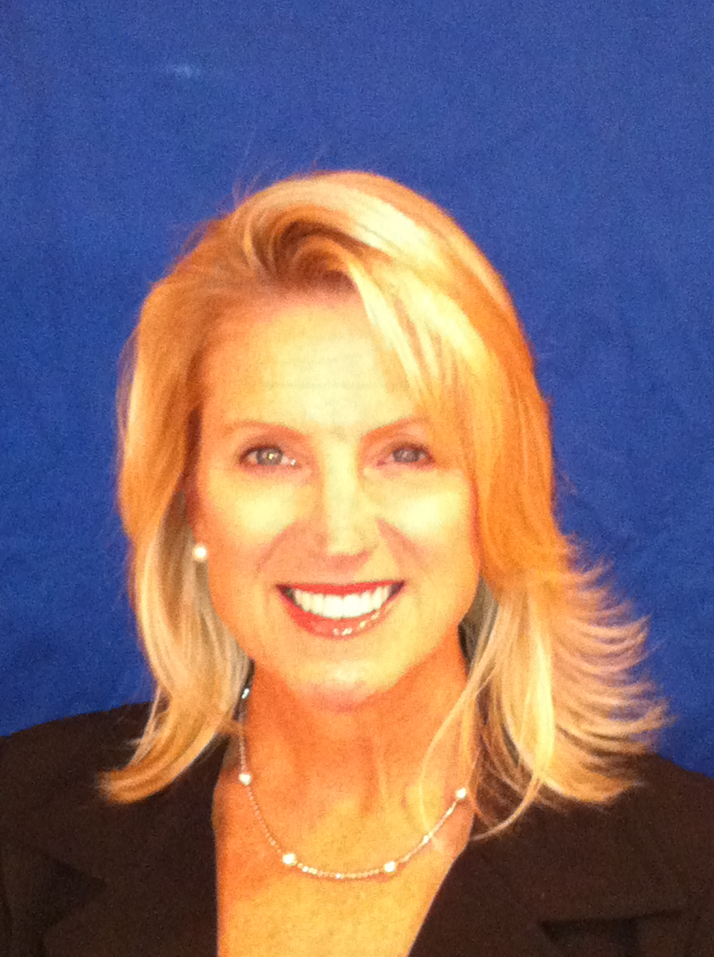
Carol Tomaselli, Director of Parish Outreach, Relevant Radio AM 950/930
Carol is part of the team promoting Relevant Radio throughout the Catholic Community and beyond. Relevant Radio exists to assist the Church in the New Evangelization by providing relevant programming through media platforms to help people bridge the gap between faith and everyday life. As Director of Parish Outreach, Carol coordinates events and assists with the station’s overall promotion of “our Catholic voice.” Before joining Relevant Radio, Carol served as Practice Manager/Marketing Coordinator, Chicago Smile Design, as General Contractor, Reese Development Corporation and as Financial Aid Director for The International Academy of Design & Technology, Chicago. She has also served in a volunteer capacity as event coordinator for Loyola Academy Wilmette, and Queen of All Saints Parish, Chicago and as Committee Chair for Boy Scouts of America, Troop 72 Skokie.

Carol graduated from DePaul University with a B.A. in Communications. Feel free to contact Carol regarding the following upcoming Relevant Radio local events: 1st Catequiz $1,000 winner, St. Mary of the Angels – January 23, 2013, Fr. Rocky’s Marriage Insurance, Willows Academy, -February 15, 2013, 1st Southside Luncheon - February 28, 2013, Northside Luncheon - April 25, 2013 and Christ Bring Hope Award Dinner - October 10, 2013.

